Moja Reporting Tool User Interface Guide

# Load Database

1. Select ‘Databases’ from the menu on the left of the screen
2. Click on the add database button +

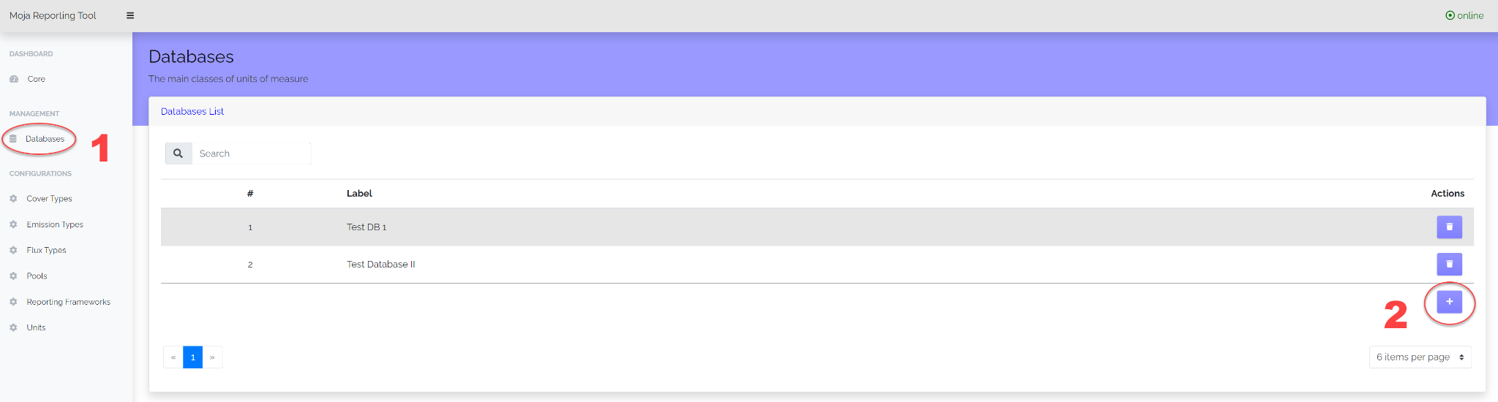

1. Enter the database URL: this is the URL for the database in PGADMIN
2. Give the database a meaningful label according to your naming conventions
3. Provide a detailed description of the database
4. Enter the start and end year of the database. This is the start and end year for the results contained in the database.
5. Select ‘Save’ and the Reporting Tool will begin processing the database, once it is ready the results can be viewed in the Dashboard

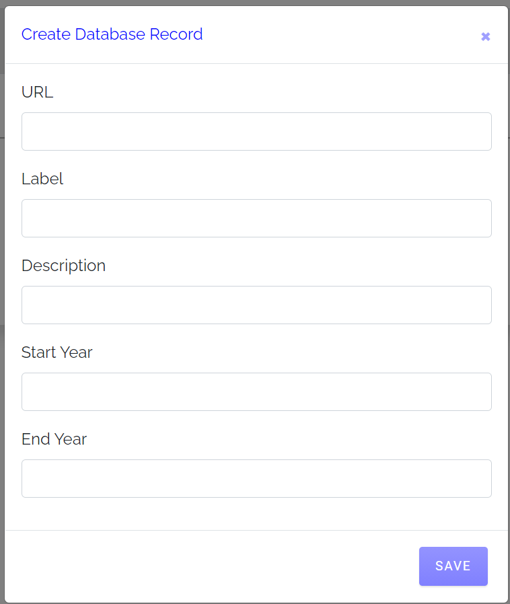

1. Open the Reporting Tool ‘Dashboard’ by selecting ‘Core’ from the menu on the left of the screen.
2. Select the database that you wish to view from the dropdown list of databases (Note that all data in this guide has been made up for testing).

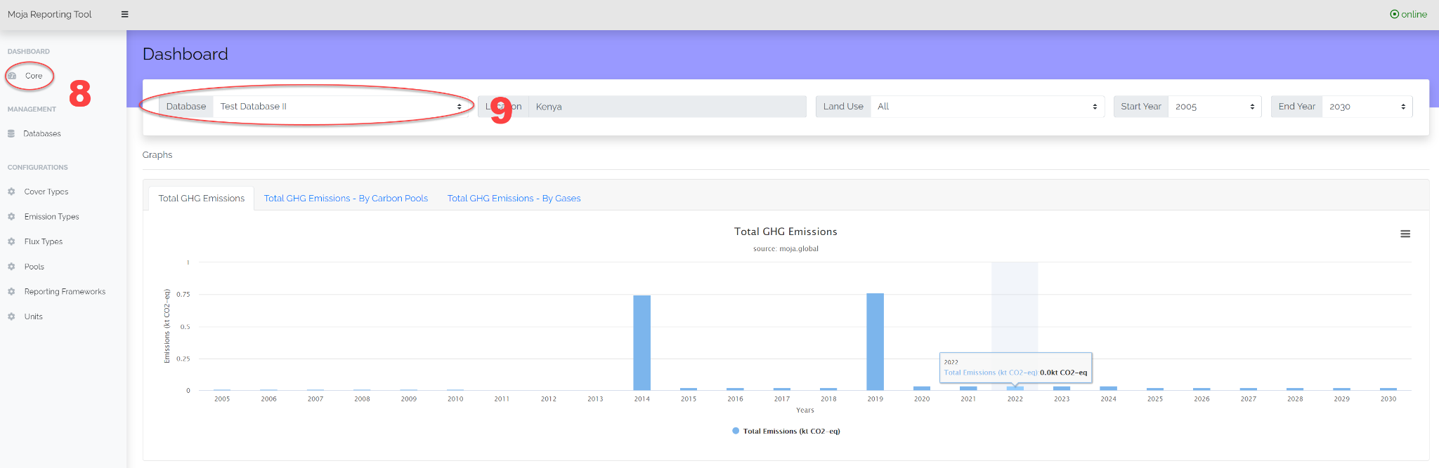

1. Once you have selected your database you may select the location (a) you are interested in, the Land Use classification (b) that you would like to view and filter according to the start and end year (c) you are interested in. The available locations, land uses and years will be dependent upon the database that you are viewing.



1. The results in the graph can be viewed as Total GHG Emissions, Total GHG Emission by carbon pools and Total GHG Emission By gasses. Note that the initial version of the tool only supports CO2.

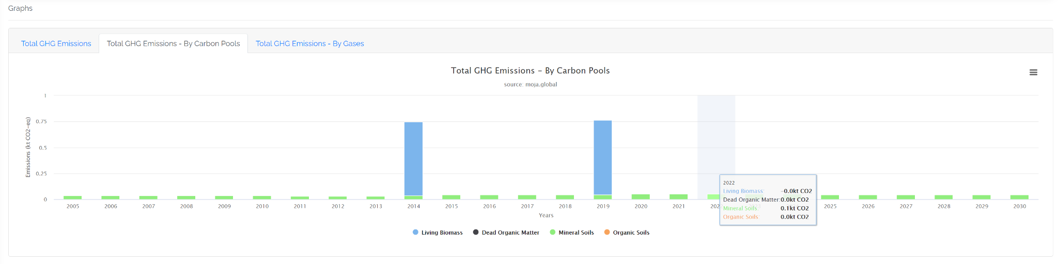

1. The results tables are presented in standard net carbon stock change in each of the carbon pools. The table results can be viewed according to each of the high level Land Use Classifications depending upon the land use classes in your database (eg Forest land, Cropland, Grassland etc).
2. The results of the Reporting Tool are downloadable as standard spreadsheets and can be downloaded at the bottom right of the ‘Dashboard’ screen.

